ZCID Rate Notification Form Guide

This guide will allow you to better understand the components provided in a Detailed ZCID Rate Notification Form. Listed below are descriptions for each section of the form:
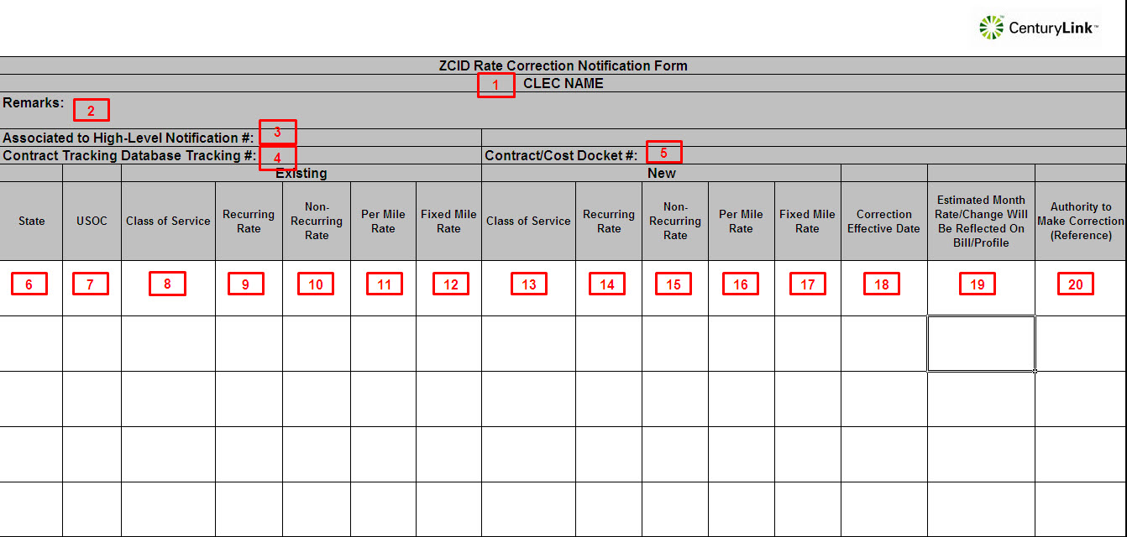

Detailed ZCID Rate Notification Form Field Descriptions
- CLEC Name – This field will have the RSID/CLEC ID and the CLEC Name
- Remarks – This field will contain summary information about the changes that are detailed in the fields below
- Associated to High-Level Tracking # - This is a batch tracking number used to associate the High-Level Notification to this Detailed Rate Change Notification
- Contract Tracking Database Tracking # - This is a number used internally to identify this Notification with it’s entry in the Contract Tracking Database
- Contract/Cost Docket # - This is the contract or cost docket number that was used as the source for the changes detailed in the fields below
- State – State affected by change, changes related to multiple states may be included in a single Notification Form
- USOC – Existing Universal Service Order Code impacted to the change
- Existing Class of Service – Code used to associate a USOC to a Product related to the change
- Existing Recurring Rate –Recurring Rate currently being billed, if blank this rate is being added to the systems, if rate is not impacted, the field will contain ‘NA’
- Existing Non-Recurring Rate - Non-Recurring Rate currently being billed, if blank this rate is being added to the systems, if rate is not impacted, the field will contain ‘NA’
- Existing Per Mile Rate - Per Mile Rate currently being billed, if blank this rate is being added to the systems, if rate is not impacted, the field will contain ‘NA’
- Existing Fixed Mile Rate - Fixed Mile Rate currently being billed, if blank this rate is being added to the systems, if rate is not impacted, the field will contain ‘NA’
- New Class of Service – Code used to associate a USOC to a Product related to the change
- New Recurring Rate –Recurring Rate that will be billed after the rate/profile correction
- New Non-Recurring Rate - Non-Recurring Rate that will be billed after the rate/profile correction
- New Per Mile Rate - Per Mile Rate that will be billed after the rate/profile correction
- New Fixed Mile Rate - Fixed Mile Rate that will be billed after the rate/profile correction
- Correction Effective Date – Date at which the change become effective in the Ordering and Billing Systems
- Estimated Month Rate/Change Will Be Reflected On Bill/Profile – Estimated Month Rate/Change Will Be Reflected On Bill/Profile
- Authority to Make Correction (Reference) – Typically this is the contract or cost docket number that was used as the source for the changes detailed in the fields below

